

Vidyavardhini’s College of Engineering & Technology

Department of Artificial Intelligence and Data Science (AI&DS)

|  |  |
| --- | --- |
| **Name:** | Vinith Shetty |
| **Roll No:** | 55 |
| **Class/Sem:** | SE/IV |
| **Experiment No.:** | 5 |
| **Title:** | Program to display string in Lowercase. |
| **Date of Performance:** | 20/02/2024 |
| **Date of Submission:** | 27/02/2024 |
| **Marks:** |  |
| **Sign of Faculty:** |  |

**Aim:** Program to display string in Lowercase.

**Theory:**

The program will take Uppercase string as input and convert it to lowercase string. Int 21h is a DOS interrupt. To use the DOS interrupt 21h load with the desired sub-function. Load other required parameters in other registers and make a call to INT 21h.

INT 21h/AH = 9

output of string at DS: ۰ String mest be terminated by '"$"

example :

org 100h

mov dx, offset msg

mov ah, 9

int 21h

ret

msg db "hello world $"

INT 21h/AH = 0AH – input of string to DS:DX, first byte is buffer size, second byte is number of chars actually read this function does not add ‘$’ in the end of string to print using INT 21h/AH = 9 you must set dollar character at the end of it and start printing from address DS : DX + 2. The function does not allow to enter more characters than the specified buffer size.



**Algorithm:**

1. Start.

2. Initialize the Data Segment.

3. Display message -1.

4. Input the string.

5. Display message-2.

6 Take the character count in CX.

7. Point to the first character.

8. Convert it to Lowercase.

9. Display the character.

10. Decrement the character coun.

11. If not Zero, repeat from step 6.

12. To terminate the program, using the DOS interrupt:

1) Initialize AH with 4CH

2) Call interrupt INT 21H.

13. Stop.

CODE:

org 100h

.data

m1 db 10,13,'Enter the string:$'

m2 db 10,13,'The string is:$'

buff db 80

.code

lea dx,m1

mov ah,09h

int 21h

lea dx,buff

mov ah,0ah

int 21h

lea dx,m2

mov ah,09h

int 21h

mov cl,[buff+1]

lea bx, buff+2

L1:mov dx,[bx]

mov ah,02h

int 21h

inc bx

LOOP L1

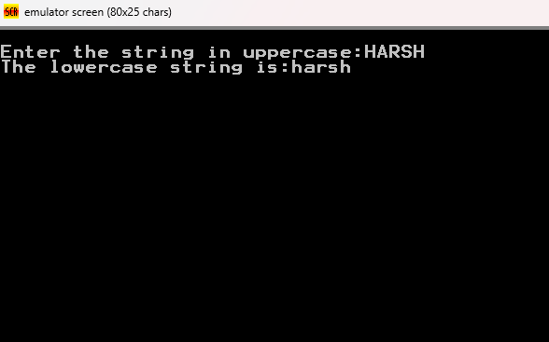

1. Explain instruction AAA.

Explain inThe AAA (Authentication, Authorization, and Accounting) framework is a security model used to control access to computer resources and manage user permissions. Here's a brief overview of each component:

Authentication: This is the process of verifying the identity of a user or system. It ensures that the entity trying to access a resource is who it claims to be. Common authentication methods include passwords, biometric scans, security tokens, and multi-factor authentication.

Authorization: Once a user or system is authenticated, authorization determines what actions they are allowed to perform and what resources they can access. Authorization is based on the user's identity and the permissions associated with that identity.

Accounting: This involves tracking and logging the actions of authenticated users. It provides a record of who accessed what resources, when, and what actions they performed. This information is valuable for security auditing, monitoring, and billing purposes.

Explain Instruction AAS.

"AAS" can refer to several things depending on the context. Here are a few possibilities:

* Authentication as a Service: AAS in this context refers to a cloud service that provides authentication functionality to applications and systems. It allows developers to offload the task of managing user identities and authentication mechanisms to a third-party service.
* Authorization as a Service: AAS can also stand for Authorization as a Service, which is similar to Authentication as a Service but focuses on managing access control and permissions for resources.
* Analytics as a Service: AAS can also refer to Analytics as a Service, which is a cloud-based service that provides data analytics tools and capabilities to organizations without the need for them to invest in and maintain their own analytics infrastructure.
* Anything as a Service: AAS is sometimes used as a generic term to refer to any service that is provided over the internet or a network, typically in a cloud computing environment. Examples include Infrastructure as a Service (IaaS), Platform as a Service (PaaS), and Software as a Service (SaaS).

**CONCLUSION**

This assembly language program reads a string input from the user, stores it in a buffer, and then prints the entered string back to the user. Here's a summary of what each part of the program does:

* Displays a prompt asking the user to enter a string.
* Reads a string input from the user and stores it in the buffer.
* Displays a prompt indicating that the entered string will be shown.
* Prints the entered string back to the user character by character.

The program essentially demonstrates how to read a string input from the user and then print it back.